ToolGator – Portsmouth based tool hire system:

**Discussion**

Background:

Located in Portsmouth on Fratton Industrial Estate, ToolGator is a small scale hire warehouse that allows for flexible term loans of tools and construction equipment to tradesmen. During peak times, ToolGator averages 15 customers per hour (8am – 10am) and only a single customer off-peak.

The centre has to monitor all tools currently in their inventory – preventing an overflow of orders for an out of stock item. It also must keep track of the return date of each hired tool, its owner, as well as the pending days until its return. Each tool is inspected when returned and its condition recorded, consequently ensuring that each item conforms to any regulations and is safe to use for the next customer.

ToolGator presently utilises a logbook paper based system to record the status of tools and the log of past hires. Problems arise during busy hours in the warehouse in which if a booking is not written immediately the staff member may forget to record it; creating a discrepancy between the warehouse’s inventory and what is logged so the company may lose track of tools if they are not returned, ultimately costing money. The warehouse’s inventory, rentals, and customer details are all stored in separate logbooks as to keep data organised. With a paper based system the data is vulnerable to damage or theft because all data must be recorded to a physical copy, risking permanent loss if backups aren’t made. In addition, illegible handwriting is a concern since it can be difficult to read at times, potentially casing errors if data is misread.

ToolGator requires a complete modernisation of its tool hire structure, making it an ideal centre for which to base this new system. While it is important to retain prior functionality, the new management program should focus on the aforementioned weaknesses, therefore mitigating the major problems of pen and paper and ensuring that the data is correctly logged with a lower risk of human error.

An intuitive user interface will ensure that employees will know how to operate the system effectively so that the transition to the new software is simple.

Stakeholder Identification – people with a vested interest in the tool hire system:

|  |  |
| --- | --- |
| Staff Member | Job Description |
| Nigel Bones – Manager | The manager is responsible for running ToolGator, taking care of staff work times, and adding new stock to the inventory.  If necessary, he can take the role of a staff member. Responsible for buying stock.  The manager would benefit from a renovated system due to fewer errors that may result in lost productivity / profit. |
| David Kirk – Counter Staff | Counter staff is responsible for facilitating customers at the desk. Records customer details in the logbook as well recording each hire in the rental logbook. Keeps the current system up to date.  The hire process should be more efficient with a computerised system, less time should be spent searching the logbooks. |
| Fred Scott – Equipment inspector/Counter Staff | The equipment inspector is responsible for ensuring that all equipment is in adequate condition, carrying out necessary repairs to equipment and noting down additional details in the inventory log. He is also responsible for cross checking the inventory with the logbook on a regular basis to ensure that recorded data is correct. |
| John Riker – Part Time Counter Staff | Counter staff is responsible for facilitating customers at the desk. Records customer details in the logbook as well recording each hire in the rental logbook. |
| Bernard Troi – Part Time Cleaning and Maintenance | Responsible for cleaning of the warehouse and general building maintenance. Has little to no vested interest in the functionality of the hire system - he does the cleaning. |

Presentation to students:

As a prerequisite to receiving feedback and the potential ideas of others, presentation was given outlining the basics of Toolgator’s current system in addition to some features that could only be accomplished by a computerised replacement.

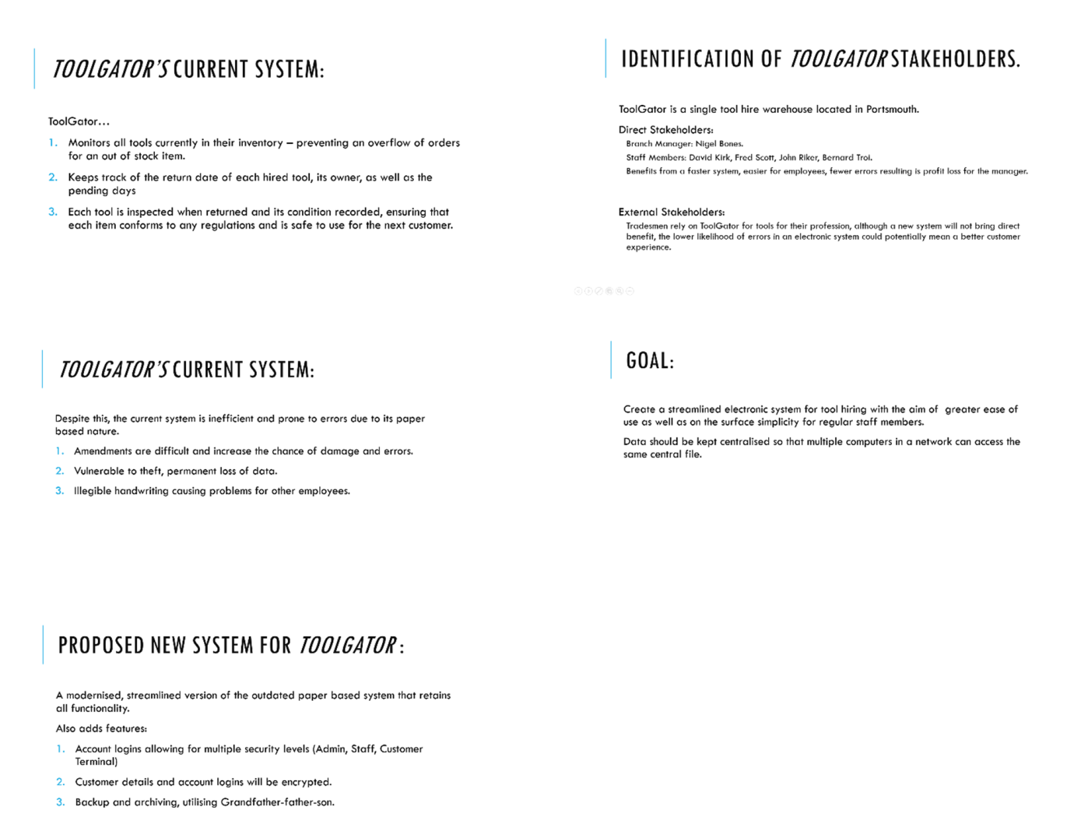

Feedback form provided to students:

After conducting the ToolGator presentation to other students on the computer science course, the following questions are posed using a Google form.

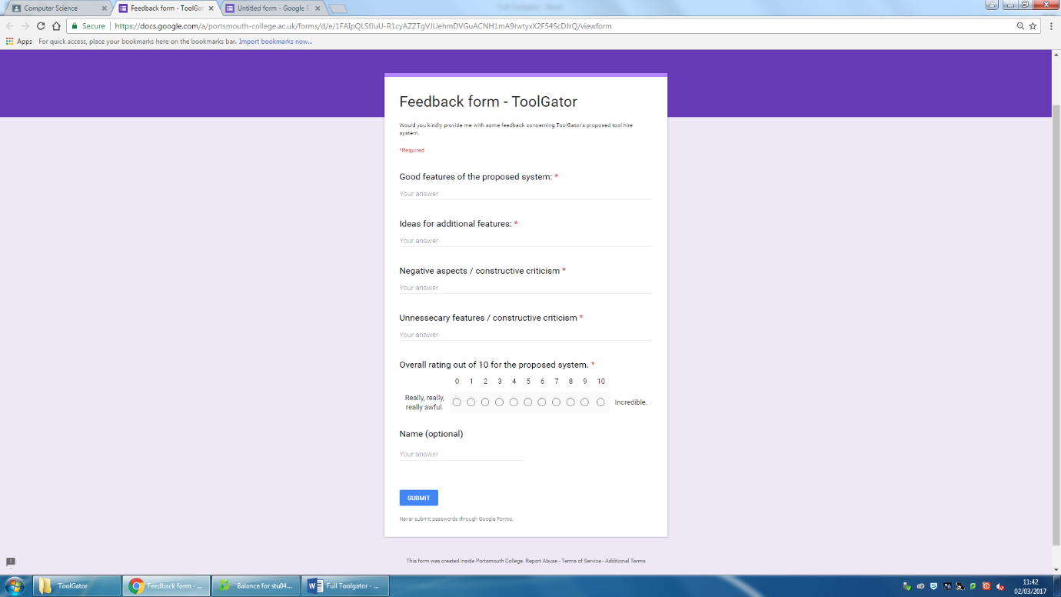

Received Feedback:

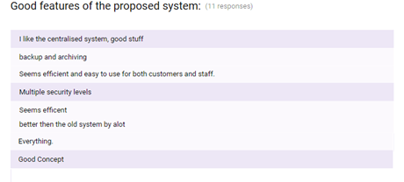

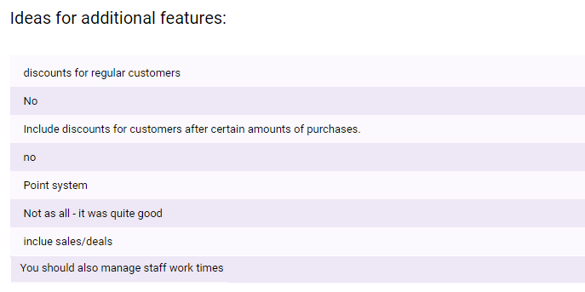



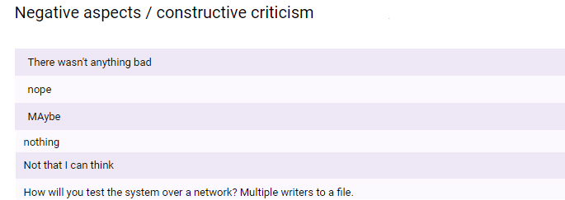

Response to Feedback:

Overall, feedback was positive for the new proposed system having received a median 8/10 and a mean 7.81/10.

The posed question “Good features of the proposed system” received encouraging feedback for the features to be debued in the electronic system:

A **centralised system** will certainly be persued with the master files being located on the staff/admin computer and various customer terminals being allowed only read priviliges across the store – providing that the terminal has the file path. This differs from the original strategy to have multiple staff/admin level computers reading and writing to files because I am not equipped with the tools to test a complex system over a local area network; resulting in a compromise to only have a single computer with write priviliges.

The plan for **file backup and archiving** is now highly likely since its commendation in the feedback, it will be included and utilised. Implementation would use the operating system’s data and time to automatically write file backups to another location per user specified time period.

Additional features were suggested, a loyalty points system in which discounts are awarded to regular customers should be included in the program. The **loyalty point** algorithm should be programmable using the GUI by any staff member with an **Admin privilige**. Points will be added to a customer’s details and can be redeemed for discounts. Such a system will enourage customer reliability and benefit ToolGator. As of this time, the approach to which such a system will be implemented is undecided, however, it should take advantage of being in place on an electronic system – adding points automatically on customer transaction.

Furthermore, a point was raised that the new system should manage staff work times – a feature that will, with most likelihood, not be included because it is out of the scope of the system’s objective; to create a system to manage tools and registered customers.

To conclude, the creation of the system will proceed as planned, but also including the suggested loyalty system for customers.

**Summary:**

Feedback highlighted the following points to attention to which I previously overlooked:

* **Inclusuion of automatic backup and archiving** – necessary to mitigate the effects of data loss. Should also include the ability create a backup at the user’s desire.
* **Potential implementation of loyalty points** – an additional feature that may encourage customers to continue using ToolGator. Should be an automated process.
* **Multiple views from customer terminals to central files**. Necessary for the potential for in-store customer computers that can browse the inventory.
* **Multiple user priviliges; admin, staff, customer terminal**. An admin account should be able to aceess all areas of the program including adjust pricing/loyalty point algorithms. Staff can take out and return tools for customers. The customer terminal can only browse the stock.
* **Encryption** of customer and staff details. As with any computer system connected to the internet, there is a risk of malicious attacks with the intent of stealing information. Although a firewall and antivirus should be in use, the encryption of customer details will provide an additional layer of protection if the files are accessed.
* **Customer details should be deleted from the system if they have not made a transaction within the span of a year.** In accordance with the Data Protection Act, customer data should not be retained for longer than necessary, however, no exact time period is specified.
* Limitation - System operates on a local level due to lack of equipment to create a networked system – only one computer can write to the central files.
* Limitation – No protection on file theft. Despite the fact that encryrption is planned to be in place, files may still be copied by an employee.